Midterm 2
Midterm 1 Review: Midterm 1 Study Guide
Section 2.2: The Inverse of a Matrix
Definitions
- Invertible Matrix
  - An n x n matrix A where 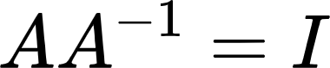
- Inverse of a Matrix
  - A⁻¹ where
- Singular
  - Not invertible
- Determinant of a 2x2 matrix
  - ad - bc
- Elementary Matrix (E)
  - Matrix obtained by performing a single row operation on an identity matrix
  - Are invertible: inverse of an elementary matrix, E, is another elementary matrix of the same type that transforms E back to I
  - All elementary matrices are invertible
- Row Equivalent Matrices
  - Matrices that can transform into each other through a sequence of elementary row operations

Key Notes
- Invertible = nonsingular
- Not invertible = singular
- Inverse of a 2x2 Matrix
  - 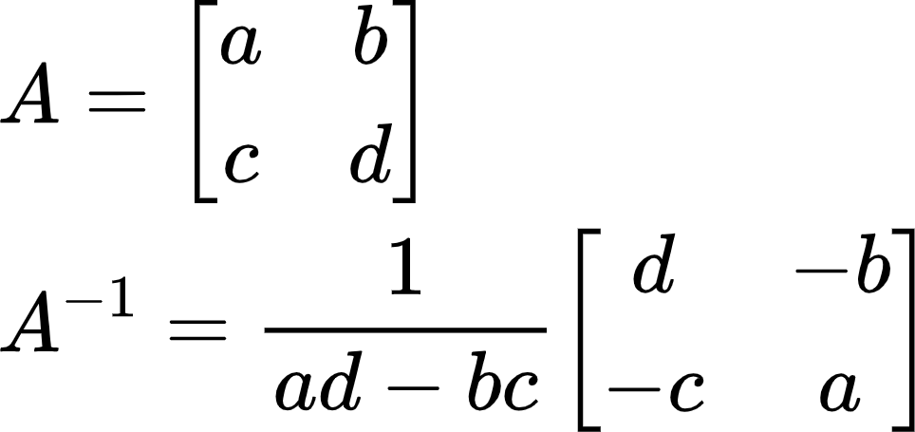
    - If (ad - bc) = 0, then A is not invertible
- Ax = b can be rewritten using inverses only if A is invertible
  - 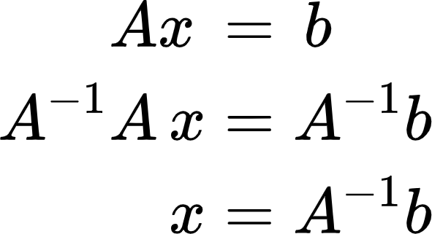
  - Of course, you can still use the row reduction method to solve Ax = b
  - For all b in R^{n}, x = A⁻¹b is a unique solution
    - Invertible matrices have no free variables
    - Unique solution
- Product of n x n invertible matrices is invertible
  - Inverse of product is the product of the inverses in reverse order
- When an elementary row operations is performed on an m x n matrix A, the resulting matrix can be written as EA
  - What if we had multiple elementary row operations on A?
- Method to find the inverse
  - Row reduce A to the identity matrix while performing the same row operations on the identity matrix at the same time
  - [A | I] => [I | A⁻¹]
- A matrix is invertible if and only if it is row equivalent to the identity
  - Pivots in every row and column (onto & one-to-one)

Section 2.3: Characterizations of Invertible Matrices
Definitions
- Linear Transformation
  - Mapping between two vector spaces (R^{n}’s) that preserves all vector addition & scalar properties
- Invertible Linear Transformation
  - Linear transformation T: R^{n} -> R^{n} is invertible if there is another linear transformation S: R^{n} -> R^{n} such that:
    - S(T(x)) = x for all x in R^{n}
    - T(S(x)) = x for all x in R^{n}
  - Equivalent to saying:
    - A⁻¹Ax = (I)x

Key Notes
- The IMT
  - 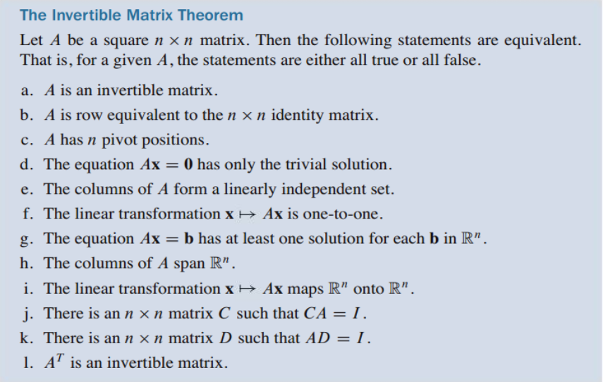
- Let A and B be square matrices:
  - If AB = I, then A and B are both invertible
  - B = A⁻¹ & A = B⁻¹
- How to determine if a linear transformation is invertible?
  - Let a matrix A represent the linear transformation
  - If A is invertible, then the linear transformation is invertible
    - 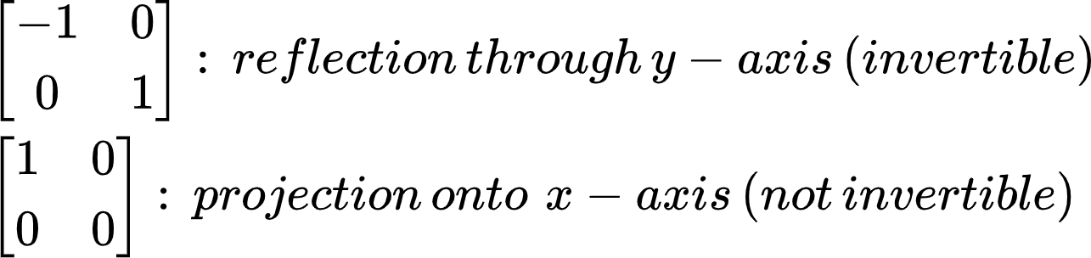

Section 2.4: Partitioned Matrices
Definitions
- Partitioned Matrix
  - Matrix divided up into separate blocks
- Block Diagonal Matrix
  - A partitioned matrix where all blocks except the main diagonal are 0’s
  - Is invertible if the main diagonal blocks are invertible

Key Notes
- Adding 2 partitioned matrices A and B
  - A and B must be the same size and partitioned in the exact same way
    - Add block by block
- Scaling partitioned matrices
  - Scale block by block
- Multiplying 2 partitioned matrices A and B (A*B)
  - Column partition of A must equal row partition of B
  - Number of columns in partition A = number of rows in partition B
    - Just like multiplying regular matrices
    - (2 x 2) * (2 x 1) => (2 x 1)
    - (3 x 4) * (4 x 1) => (3 x 1)
- Inverses of Partitioned Matrices
  - 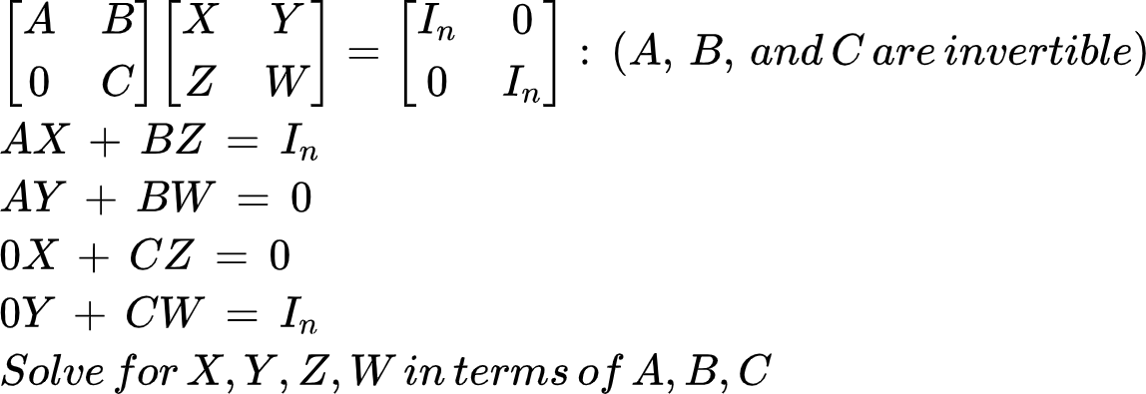

Section 2.5: Matrix Factorizations
Definitions
- Factorization of a matrix
  - Expression of a matrix as the product of two or more matrices
- Row interchanges
  - Swapping rows when row reducing
- Lower triangular matrix
  - Entries above the main diagonal are all 0’s
- Upper triangular matrix
  - Entries below the main diagonal are all 0’s
- Algorithm for an LU Factorization
  - 1. Reduce A to an echelon form U by a sequence of row replacement operations, if possible.
  - 2. Place entries in L such that the same sequence of row operations reduces L to I.

Key Notes
- LU Factorization
  - Why do we use it?
    - More efficient to solve a sequence of equations with the same coefficient matrix (Ax = b₁, Ax = b₂, ... , Ax = b_{n}) by LU factorization than row reducing the equations every single time
- Let A be an m x n matrix that can be row reduced to echelon form without row exchanges, then:
  - 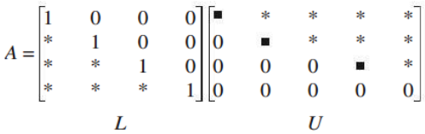
    - L: m x m lower triangular matrix with one’s on the main diagonal
    - U: m x n echelon form of A
- Rewriting Ax = b using A = LU
  - 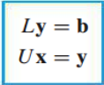
  - Ax = b -> L(Ux) = b
- The LU Factorization Algorithm
  - How do we get U?
    - Row reduce A to echelon form using only row replacements that add a multiple of one row to another below it
  - How do we get L?
    - Take the row replacement operations you did on A when getting echelon form
      - Basically: find the elementary matrices that transform A into U
    - Then, reverse the signs and input them in their respective spots in the m x m identity matrix
      - Replace the 0’s below the main diagonal with the row replacement “coefficients”
      - Basically: after finding all the elementary matrices, take their inverses
  - 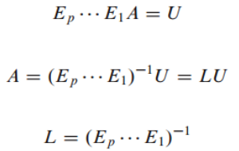
- Using the LU Decomposition
  - After constructing A = LU, solve Ax = LUx = b by:
    - 1. Forward solve for y in Ly = b
      - R1(x) + R2 -> R2
      - Modify rows below using above rows
    - 2. Backwards solve for x in Ux = y
      - R2(x) + R1 -> R1
      - Modify rows above using below rows

Section 2.6: The Leontief Input-Output Model
Definitions
- Production vector in R^{n} (x)
  - Lists the output of each sector for one year
- Final demand vector (d)
  - Lists the value of goods and services produced for the consumers (nonproductive part of the economy)
- Intermediate demand (Cx)
  - The demand for goods and services that the producers (sectors) need as inputs for their own production
    - Ex: electricity sector needs inputs from the water sector and vice versa
- Consumption matrix (C)
  - How much each sector consumes from other sectors in terms of percentages
- Column sum
  - The sum of the entries in a column

Key Notes
- The Leontief Input-Output Model (Production Equation)
  - 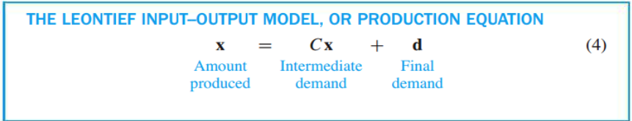
  - Can be rewritten as:
    - (I - C)x = d
      - Solve for x (amount produced) by row reduction
    - x = (I - C)⁻¹ * d
      - Solve for x (amount produced) by multiplying
- For a good economy, the column sum of each sector should be less than 1
  - A sector should in general require less than one unit’s worth of inputs to produce one unit of output
- Output vector (x)
  - x_{i}: entry i of vector x
    - Number of units produced by sector i
- Internal consumption (C)
  - 2 equivalent ways of defining entries of C where an entry is c_{i, j}:
    - Sector i sends a proportion of its units to sector j
    - Sector j requires a proportion of the units created by sector i
- Consumption matrix (Cx)
  - Total output for each sector (per one unit) is the sum of the columns for each sector
- A Formula for (I - C)⁻¹
  - As an economy is introduced to a demand vector, the equation starts off as:
    - x = d
  - However, production will require intermediate demand from other sectors, and then that intermediate demand will require more inputs from even more sectors
    - x = d + Cd + C²d + C³d + …
      - => (I + C + C² + C³)d
  - 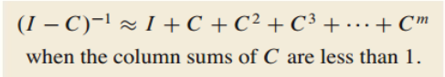
    - We can approximate (I - C)⁻¹ by making m as large as possible
      - Add as many intermediate demands as we can
- Economic Importance of Entries in (I - C)⁻¹
  - Entries used to predict how the production x will have to change when the final demand d changes
    - Remember: x = (I - C)⁻¹ * d
  - The entries in each column of (I - C)⁻¹ are the increased amounts each sector has to produce in order to satisfy an increase of 1 unit in the final demand

Section 2.7: Applications to Computer Graphics
Definitions
- Homogeneous coordinates
  - Each point (x, y) in R² can be identified with the point (x, y, 1) on the plane in R³ that lies one unit above the xy - plane
- Composite transformations
  - Multiplication of 2 or more basic transformations

Key Notes
- Why do we use homogeneous coordinates?
  - Translations are not linear transformations
- Homogeneous coordinates are allowed to be scalars
  - (3, 5, 1) = (6, 10, 2)
- (x, y) -> (x + h, y + k)
  - Translation cannot be represented by an R² matrix multiplication
  - (x, y, 1) -> (x + h, y + k, 1)
  - 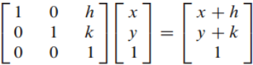
    - Translation not possible if we used a 2x2 identity matrix
- Linear transformations in R² represented with homogeneous coordinates are written as partitioned matrices:
  - 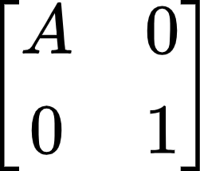 where A is a 2x2 matrix
  - Examples
    - 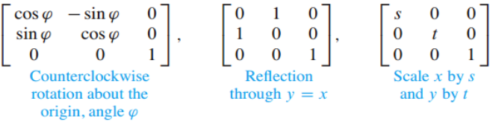
- Composite Transformations
  - “Add” on more transformation matrices to the left of the other transformations
    - First transformation is always the rightmost (modifies the x vector first)
- Homogeneous 3D Coordinates
  - (X, Y, Z, H) are homogeneous coordinates for (x, y, z) if H ≠ 0 and
    - 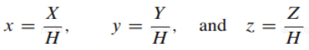

Section 2.8: Subspaces of R^{n}
Definitions
- Subset of R^{n}
  - Any collection of vectors that are in R^{n}
- Subspace of R^{n}
  - A subset H in R^{n} that has 3 properties:
    - The zero vector is in H
    - 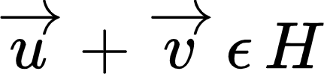 (closed under addition)
    - 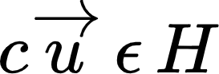 (closed under scalar multiplication)
  - Subspace can be written as the Span{} of some amount of linearly independent vectors
- Column Space of a Matrix A (m x n)
  - Col A: the subspace of R^{m} spanned by {a₁ , … , a_{n}}
  - Essentially all the pivot columns
- Null Space of a Matrix A (m x n)
  - Null A: the subspace of R^{n} spanned by the set of all vectors x that solve Ax = 0
- Basis for a Subspace H of R^{n}
  - A linearly independent set in H that spans H
    - DOES NOT CONTAIN THE ZERO VECTOR (BECAUSE IT IS LINEARLY INDEPENDENT) UNLIKE THE SPAN
- Standard Basis for R^{n}
  - {e₁ , … , e_{n}}

Key Notes
- If v₁ and v₂ are in R^{n} and H = Span{v₁ , v₂}, then H is a subspace of R^{n}
  - v₁ and v₂ must be in R^{n} for this relation to work
- For v₁, … , v_{p} in R^{n}, the set of all linear combinations of v₁, … , v_{p} is a subspace of R^{n}
  - Span{v₁ , … , v_{p}} = subspace spanned by v₁ , … , v_{p}
- Is b in the column space of A?
  - Same as : Is b a linear combination of A?
  - Same as : Is b in the Span of A?
- Is H a subspace of R^{n}?
  - Basically asking if H has n linearly independent columns
  - Does H have no free variables?
- Subspaces vs. Bases
  - Subspaces => Span{v₁ , … , v_{n}}
    - Includes the 0 vector
  - Bases => {v₁ , … , v_{n}}
- Defining a basis for column space A
  - Number of entries for each vector = number of rows in matrix A
  - Number of vectors in the basis = number of pivot columns
  - What vectors can you include in the basis?
    - Scalar multiples
    - The identity matrix columns only if every column is pivotal in A
- Finding the Column Space
  - Row reduce the matrix
    - Row operations do not affect linear dependence relations
  - Determine the pivot columns
  - Create a basis/subspace using the pivot columns in the original matrix
    - Not the row reduced one
  - If every column is linearly independent, then the elementary vectors are included in the column space
    - Linear combinations of elementary vectors can get you any column of the original matrix
- Finding the Null Space
  - Determine all the free variables
  - Rewrite system in parametric vector form
  - Vectors created in parametric vector form generate the null space

Section 2.9: Dimension and Rank
Definitions
- Coordinates
  - Weights that map our vectors to get to some point in the span of the vectors
- Coordinate Vector
  - 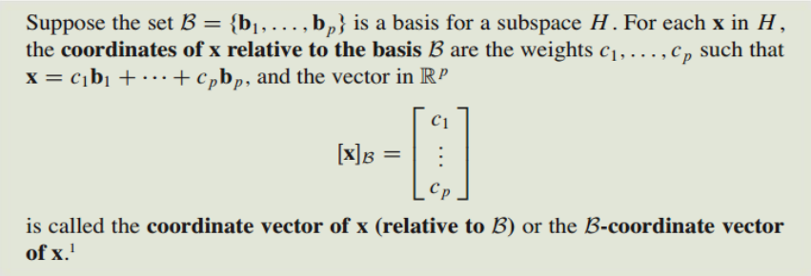
- Dimension of a Subspace
  - dim H: the number of vectors in a basis of H
  - dim{0} = 0
- Rank of a Matrix A
  - Dimension of the column space of A
  - Number of pivots in A

Key Notes
- Why we choose to write bases:
  - Each vector in H can be written in only one way as a linear combination of the basis vectors
- A plane through 0 in R³ is two-dimensional
  - 3x3 matrix A has 2 pivots
- A line through 0 in R² is one-dimensional
  - 2x2 matrix A has one pivot
- Any two choices of bases of a non-zero subspace H have the same dimension
  - dim R^{n} = n
  - dim(Col A) = number of pivots
  - dim(Null A) = number of free variables
- dim(Col A) = rank A
- Rank Theorem
  - If A has n columns, then:
    - rank A + dim(Null A) = n
  - Number of pivots + number of free variables = number of columns
- Basis Theorem
  - Any two bases for a subspace have the same dimension (cardinality)
  - Many choices for the basis of a subspace
- Continuation of the Invertible Matrix Theorem with Rank
  - 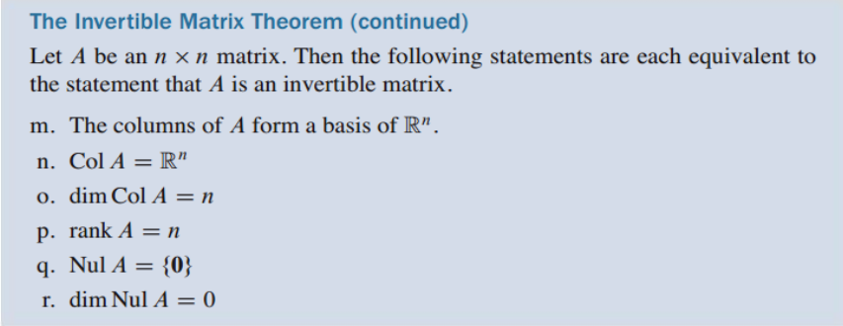

Section 3.1: Introduction to Determinants
Definitions
- A_{i j} submatrix
  - Delete the ith row and jth column of matrix A
  - Remaining elements will form the new submatrix
- Determinant for a 2x2
  - A = 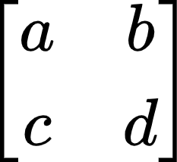 -> det A = ad - bc
- Cofactor expansion
  - A way to solve determinants for square matrices that are 3x3 and greater

Key Notes
- Signs of cofactor expansions
  - Depends on position of element a_{i j} in the matrix
  - 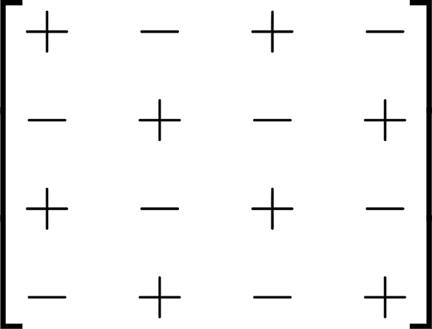
- Shortcut for finding the determinant
  - Row reduce to REF
    - Effects of row operations on determinant covered in 3.2
  - Multiply all the numbers on the main diagonal

Section 3.2: Properties of Determinants
Definitions
- Column Operations
  - Same effect on determinants as row operations
  - This is true because the determinant of A = determinant of A^{T} (transpose)

Key Notes
- Row operations on determinants
  - Row replacement: nothing
  - Row swap: multiply determinant by negative one
  - Row scale: multiply determinant by scale
- Summary of elementary matrices’ determinants
  - 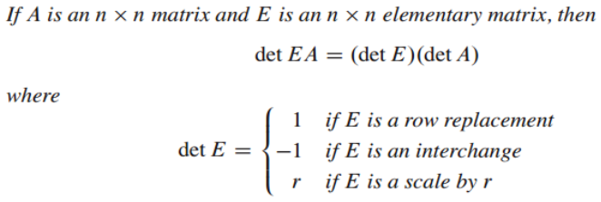
- More specific example of row scaling on determinants
  - 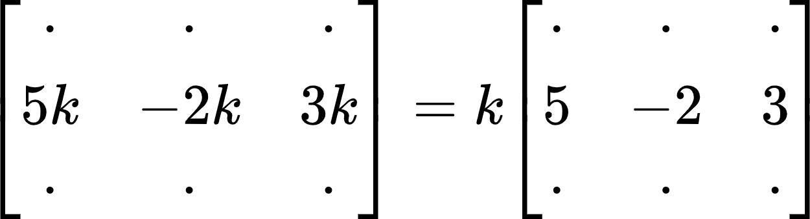
  - Row divided by k
    - Determinant is multiplied by 1/k
- If A is invertible (every column is pivotal)
  - det A ≠ 0
- If A is not invertible
  - det A = 0
  - At least one entry on the main diagonal of REF is 0
- 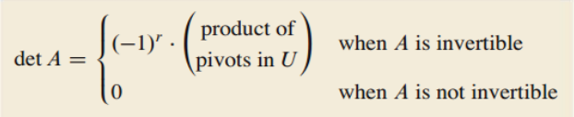
- When A is not invertible, the rows are linearly dependent
  - If A is square, then the columns are also linearly dependent
- det A = det A^{T}
- det AB = (det A)(det B)
- det A⁻¹ = 1 / (det A)

Section 3.3: Volume and Linear Transformations
Definitions
- Parallelepiped: a parallelogram in R^{n} where n > 2

Key Notes
- If A is a 2x2 matrix:
  - Area of the parallelogram determined by the columns of A is | det A |
- If A is a 3x3 matrix:
  - Area of the parallelepiped determined by the columns of A is | det A |
- Row/column swaps and replacements do not affect the absolute value of the determinant
- Linear transformations on a parallelepiped
  - Area of T(S) = | det A | * { area of S }
    - T: linear transformation determined by matrix A
    - S: parallelogram

Section 4.9: Applications to Markov Chains
Definitions
- Probability vector
  - A vector with nonnegative entries that sum to 1
- Stochastic matrix
  - A square matrix whose columns are probability vectors
- Markov Chain
  - A sequence of probability vectors {x₀, x₁, x₂, …} together with a stochastic matrix {P} such that:
- Steady State Vector
  - A probability q such that Pq = q
  - Every stochastic matrix has a steady state vector
- Regular stochastic matrix
  - Stochastic matrix where some power of it will contain only strictly positive entries
    - P^{k} where all entries > 0

Key Notes
- How to find the next outcome of a Markov Chain?
  - Simply multiply P by x_{k} to find x_{k+1}
- How to find a steady state vector?
  - 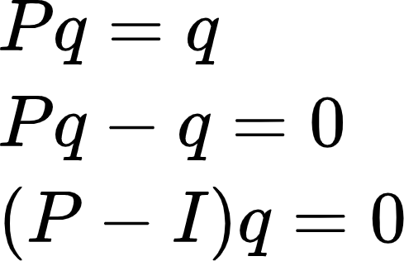
  - After finding a basis for the null space of (P - I) q = 0, remember to make sure that the column sum is 1
    - Steady state vector is a probability vector
- The initial state has no effect on the long term behavior of the Markov Chain

Section 5.1: Eigenvectors and Eigenvalues
Definitions
- Eigenvector of an n x n matrix A:
  - Nonzero vector x such that Ax = λx for some scalar λ
- Eigenvalue of A:
  - A scalar λ where there is a nontrivial solution x of Ax = λx
- Eigenspace of an eigenvalue
  - Contains the zero vector and all eigenvectors corresponding to λ

Key Notes
- Determine if a vector x is an eigenvector
  - A*x => see if product is a scalar multiple of x
- Finding the eigenvector from an eigenvalue (7)
  - Solve (A - 7I)x = 0
  - Then, do the parametric vector form of what you have left
- Finding the eigenvalue λ
  - Solve (A - λI)x = 0 for a nontrivial solution
  - Find the set of all solutions to the null space of (A - λI)
- Eigenvalues of a triangular matrix are the entries on the main diagonal
- 0 is an eigenvalue of A if and only if A is not invertible
  - Ax = 0x
  - Ax = 0: x is a nontrivial solution if A is not invertible
- Eigenvectors that correspond to distinct eigenvalues are linearly independent
  - Opposite is not always true
    - 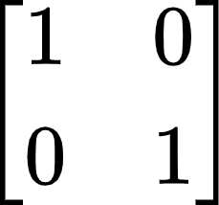: eigenvectors are linearly independent but have the same eigenvalue

Section 5.2: The Characteristic Equation
Definitions
- The Characteristic Polynomial:
  - det(A - λI)
- The Characteristic Equation
  - det(A - λI) = 0
- Trace
  - Sum of the diagonal entries in a matrix
- Algebraic Multiplicity of an Eigenvalue
  - The number of times the eigenvalue shows up as roots of the characteristic polynomial
- Geometric Multiplicity of an Eigenvalue
  - The dimension of Null (A - λI) for a given eigenvalue λ

Key Notes
- How to find eigenvalues?
  - Solve (A - λI)x = 0 for a nontrivial solution
  - Find the set of all solutions to the null space of (A - λI)
- Continuation of IMT
  - For A: n x n matrix, A is invertible if and only if:
    - The number 0 is not an eigenvalue of A
    - The determinant of A is not 0
- Finding the characteristic polynomial using trace and determinant for a characteristic polynomial of 2
  - λ² - λ(trace) + det A
- Warnings:
  - Cannot determine the eigenvalues of a matrix from its reduced from
  - Row operations change the eigenvalues

Theorems
Chapter 2
Theorem 4: Finding the Inverse of a 2x2 Matrix
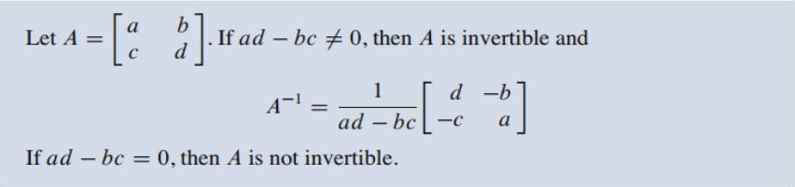

Theorem 5: Alternate Method of Finding the Solution Set

Theorem 6: Properties of Invertible Matrices
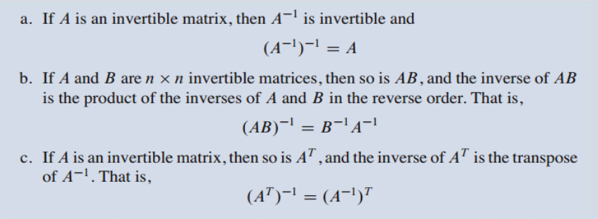

Theorem 7: Finding the Inverse of a Matrix
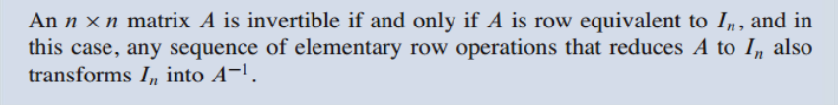

Theorem 8: The Invertible Matrix Theorem

Theorem 9: Invertible Linear Transformations
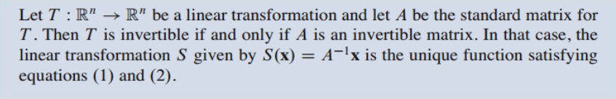
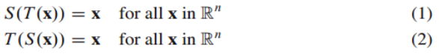

Theorem 10: Column-Row Expansion of AB
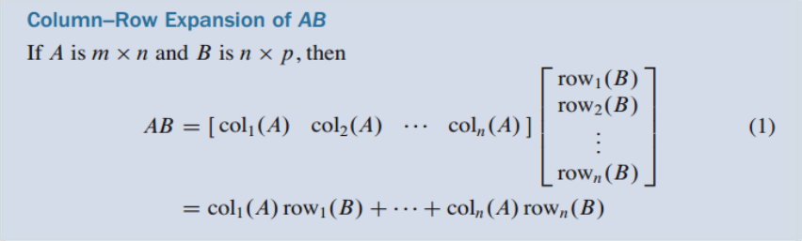

Theorem 11: Solving the Output Vector (x)
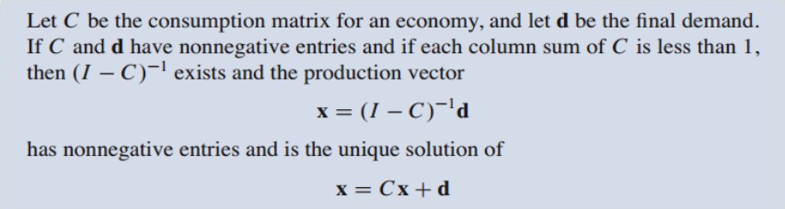

Theorem 12: Finding the Null Space of Matrix A
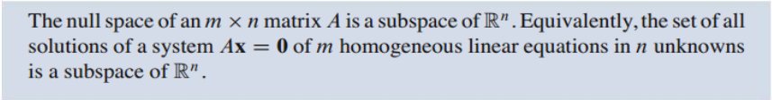

Theorem 13: Determining the Column Space of Matrix A

Theorem 14: The Rank Theorem

Theorem 15: The Basis Theorem
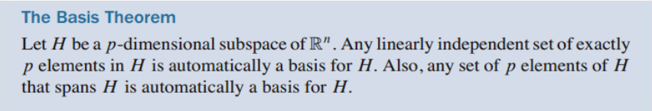

Chapter 3
Theorem 1: Cofactor Expansion to find Determinants
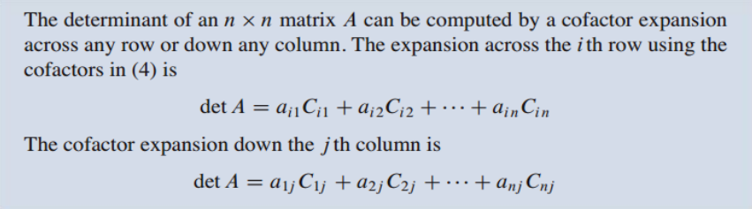

Theorem 2: Shortcut to Computing Determinant

Theorem 3: Row Operations on Determinants
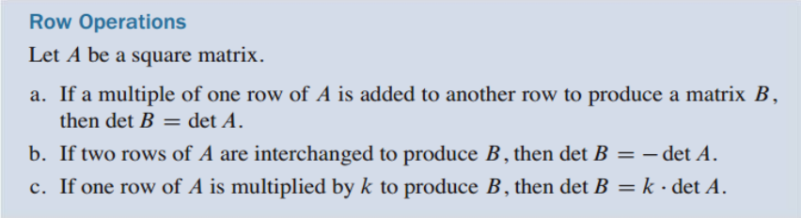

Theorem 4: IMT DLC: Determinant

Theorem 5: Transpose Equivalence for Determinants
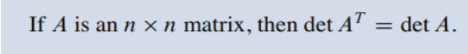

Theorem 6: Multiplicative Property of Determinants
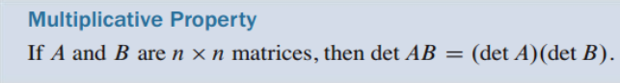

Theorem 9: Determinants as Area and Volume
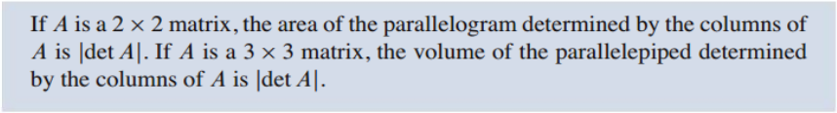

Theorem 10: Linear Transformations on Area/Volume
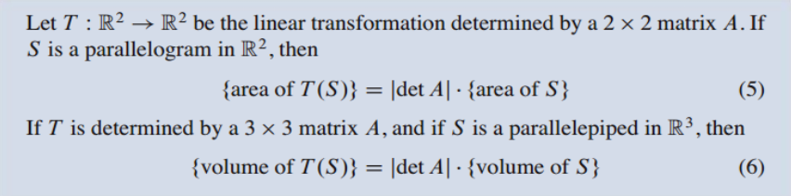

Chapter 4
Theorem 18: Long-term Behavior of a Markov Chain
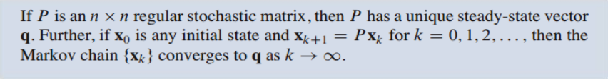

Chapter 5
Theorem 1: Eigenvalues of a Triangular Matrix

Theorem 2: Eigenvectors for Distinct Eigenvalues

