Midterm 1: Patrick Kim
Section 1.1: Systems of Linear Equations
Definitions
- Linear equation
  - a₁x₁ + a₂x₂ + … + a_{n}x_{n} = b
  - Organization of coefficients and variables with a solution ‘b’
- System of linear equations
  - Collection of multiple linear equations
- Solution of a system
  - (s₁, s₂, … ,s_{n})
  - List of numbers that make each equation a true statement when the s values are substituted for the x variables
- Solution set
  - Set of all possible solutions of a linear system
- Equivalent linear systems
  - 2 linear systems with the same solution set
- Consistent system
  - 1 solution or infinitely many solutions
- Inconsistent system
  - No solution for a specific input
- Existence
  - Does a solution set exist?
- Uniqueness
  - If a solution exists, is there more than one solution?

Key Notes
- A system of linear equations has either:
  - No solution
  - Exactly one solution
  - Infinitely many solutions
- Matrix notation
  - Rectangular format that contains info of a linear system
  - Example system
    - 1x₁ - 2x₂ + x₃ = 0
    - 0x₁ + 2x₂ - 8x₃ = 8
    - 5x₁ + 0x₂ - 5x₃ = 10
  - Coefficient matrix
    - 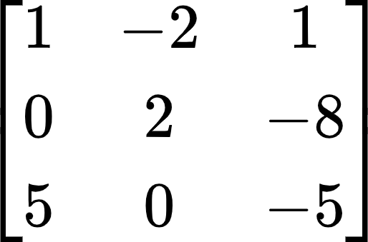
  - Augmented matrix
    - 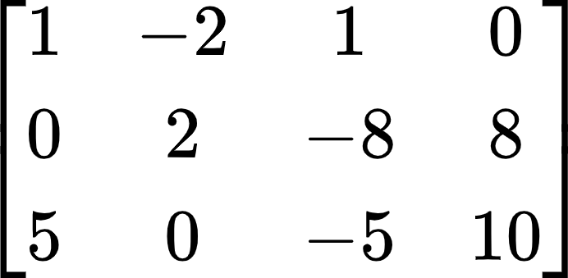
  - Size of a matrix
    - m x n
    - m: rows
    - n: columns
- Row reduction operations
  - Replacement
    - Eliminating elements (making them 0) by comparing two rows and scaling one of them
  - Interchange
    - Swapping rows
  - Scaling
    - Usually done to make a leading entry into one
- Goal of row reduction: to create an echelon form or RREF
  - Triangle of 0’s

Section 1.2: Row Reduction and Echelon Forms
Definitions
- Non-zero row/column
  - Row or column with at least one nonzero entry
- Zero row/column
  - Row or column with all zeros
- Leading entry
  - Leftmost nonzero entry in a row
- Row reduced echelon form (RREF)
  - A simplified matrix that represents a potential solution set for a linear system
  - Each matrix has only one RREF
- Pivot position
  - Location in a matrix that corresponds to a leading 1 in RREF
- Pivot column
  - Column that contains a pivot position
- Basic/leading variables
  - Variables that correspond to a pivot
  - Basic variables have an exact value for a solution set
- Free variables
  - Variables that do not correspond to any pivots and pivot columns
  - Can be assigned any value for a consistent linear system
- Overdetermined system
  - # of rows > # of columns
  - System of linear equations with more equations than unknowns
    - Can be consistent
    - Can have a unique solution
  - 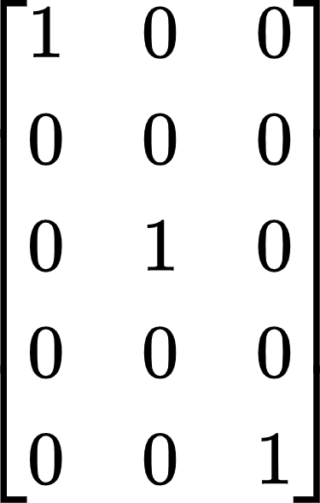
- Underdetermined system
  - # of columns > # of rows
  - System of linear equations with more unknowns than equations
  - Can never have a unique solution (always a free variable)
    - If system is consistent -> infinite solutions
    - If system is inconsistent -> no solution
  - 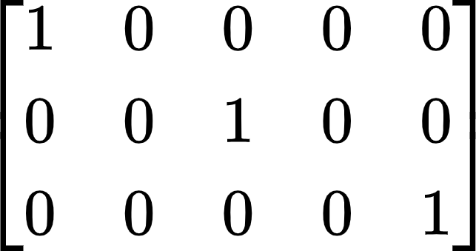

Key Notes
- Echelon Form of a Matrix
  - 3 Properties:
- All zero rows are at the bottom
- Each leading entry (non-zero entry) of a row is to the right of any leading entries in the row above it (if any)
- Below a leading entry, all entries are 0
- RREF
  - All leading entries are 1’s
  - There are 0’s above and below each leading 1
- A matrix can be in neither echelon form nor RREF
  - This means that more row reduction needs to be done
- Uniqueness of the RREF
  - Each matrix is row equivalent (has same solution set) to one and only one reduced echelon matrix
    - A matrix has only one RREF matrix
- Inconsistent systems have empty solution sets
- Existence and Uniqueness Theorem
  - A linear system is consistent if and only if the rightmost column of the augmented matrix is not a pivot column
    - No row of the form:
      - [0 0 0 0 0 | b] with b non-zero
  - If a linear system is consistent, the solution set has either:
    - Unique solution (no free variables)
    - Infinitely many solutions (at least one free variable)

Section 1.3: Vector Equations
Definitions
- Vector
  - An ordered list of numbers
- R^{n}
  - R: collection of all lists of n real numbers
  - n: number of entries (rows) in the vector
- Zero vector: 0
  - Vector with all entries 0
- Linear combination
  - Given vectors {v₁, v₂, …, v_{p}} in R^{n} and given scalars {c₁, c₂, …, c_{p}}, a vector y defined by y = c₁v₁ + c₂v₂ + … + c_{p}v_{p} is a linear combination
- Span{v₁ … v_{p}}
  - Collection of all vectors that can be written in the form
c₁v₁ + c₂v₂ + … + c_{p}v_{p}

Key Notes
- Vectors in R^{x}
  - R² vector: 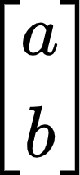
  - R³ vector:
- Vectors in R² can be represented as a line to a point in a 2D space
- Vectors in R³ can be represented as a line to a point in a 3D space
- Graphically adding vectors in R²
  - Add “tip to tail”
- Algebraic properties of R^{n}
  - For all u, v, w in R^{n} and all scalars c & d:
i. u + v = v + u v. c (u + v) = cu + cv
ii. (u + v) + w = u + (v + w) vi. (c + d) u = cu + du
iii. u + 0 = 0 + u = u vii. c (du) = (cd) u
iv. u + (-u) = -u + u = 0 viii. 1u = u
- A vector equation x₁a₁ + x₂a₂ + … + x_{n}a_{n} = b has the same solution set as the linear system whose augmented matrix is [a₁ a₂ .. a_{n} | b]
  - b can be generated by a linear combination of a₁, …, a_{n} if and only if there exists a solution (weights: x₁, …, x_{n}) to the linear system corresponding to the matrix
- If v₁ … v_{p} are in R^{n}, then the set of all linear combinations of v₁ … v_{p} is denoted by Span{v₁ … v_{p}} and is called the subset of R^{n} spanned by v₁ … v_{p}
  - Span{v₁ … v_{p}}: collection of all vectors that can be written in the form
c₁v₁ + c₂v₂ + … + c_{p}v_{p}
- Is vector b in Span{v₁, …, v_{p}}? == does x₁v₁ + x₂v₂ + … + x_{p}v_{p} = b have a solution?
  - Solve [v₁ … v_{p} | b]
  - Is b a linear combination of the vectors in {v₁ … v_{p}}?
    - Is there a pivot in every row?

Section 1.4: The Matrix Equation Ax=b
Definitions
- Identity matrix
  - The “one” of multiplying matrices
  - Outputs the same input
- x ∈ R^{n}
  - x is a vector with n elements
Key Notes
- Star Equation
  - Ax = 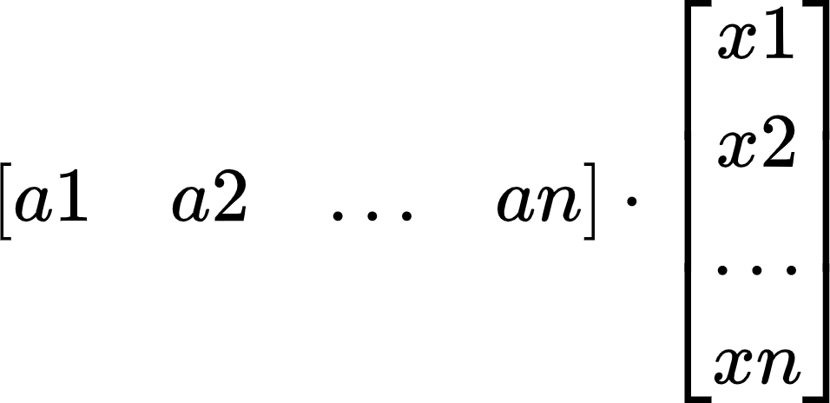 = x₁a₁ + x₂a₂ + … x_{n}a_{n}
    - x: weights
    - Ax is defined only if the number of columns in A == number of entries in x
- If A is an m x n matrix, with columns a₁, … a_{n}, and if b is in R^{m}:
  - Matrix equation == vector equation == augmented matrix for a linear system
  - (Ax = b) == (x₁a₁ + x₂a₂ + … + x_{n}a_{n} = b) == ([a₁ a₂ … a_{n} | b])
- Ax = b as a linear combination has two parts
- A vector
- x vector
  - Span of the columns essentially means multiplying these two parts
- Ax = b has a solution if and only if b is a linear combination of the columns of A
- Logically equivalent statements for an m x n matrix A (all true or all false)
  - For each b in R^{m}, the equation Ax = b has a solution
  - Each b in R^{m} is a linear combination of the columns of A
  - The columns of A span R^{m}
  - A has a pivot position in every row
- If A is an m x n matrix, u & v are vectors in R^{n}, and c is a scalar, then:
  - A(u + v) = Au + Av
  - A(cu) = c(Au)

Section 1.5: Solution Sets of Linear Systems
Definitions
- Homogeneous linear system
  - System of linear equations written in the form: Ax = 0
- Trivial solution
  - x vector = 0
- Nontrivial solution
  - x vector that satisfies Ax = 0 and has at least one non-zero element
- Nonhomogeneous linear system
  - System of linear equations written in the form: Ax = b
  - Where b != 0

Key Notes
- Homogeneous linear system (Ax = 0) always has at least one solution
  - Trivial solution: x = 0
- Homogeneous system has a nontrivial solution if there is at least one free variable
- Implicit description of a plane
  - 10x₁ - 3x₂ - 2x₃ = 0
- Explicit description of a plane (Parametric Vector Equation)
  - x = su + tv
    - x: x vector
    - s, t in R
  - x = x₂u + x₃v
    - x₂ and x₃ are free variables
- Parametric Vector Form for a consistent …
  - Ax = b
    - x = u + tv
  - Ax = 0
    - x = tv
- For a consistent Ax = b, the solution set of Ax = b is the set of all vectors of the form
w = p + v_{k}
where p is a solution and v_{k} is any solution of Ax = 0
- Writing a solution set in Parametric Vector Form
- Row reduce the augmented matrix to RREF
- Express each basic variable in terms of any free variable appearing in an equation
- Write a typical solution x as a vector whose entries depend on the free variables
- Decompose x into a linear combination of vectors using the free variables as parameters
  - Ex: 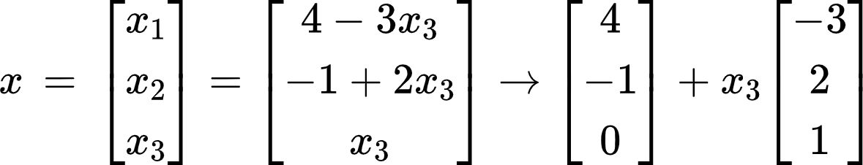
[p] [v]

Section 1.7: Linear Independence
Definitions
- Linearly independent
  - Vector equation x₁v₁ + x₂v₂ + … + x_{p}v_{p} = 0 has only the trivial solution
  - Matrix A has a pivot in every column
  - No free variables
- Linearly dependent
  - Vector equation c₁v₁ + c₂v₂ + … + c_{p}v_{p} = 0 where weights c₁, … , c_{p} are not all zero
  - At least one free variable

Key Notes
- If a set of vectors is linearly independent, there are no free variables
  - No free variables = pivot in every column
- If a set of vectors is linearly dependent, there is at least one free variable
- Quick facts
  - If # of columns > # of rows, then {v₁, …, v_{p}} is linearly dependent
    - 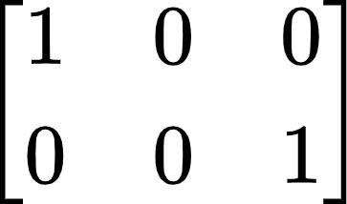: x₂ is free
  - If {v₁, …, v_{p}} is linearly independent, then # of rows ≥ # of columns
    - 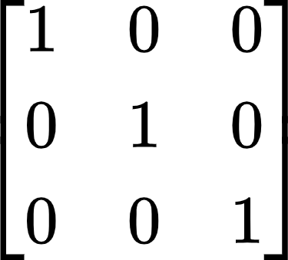: no free variables
    - 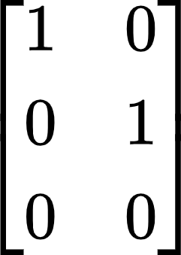: no free variables (there is no x₃ here)
  - If Ax = 0 has a free variable, then {v₁, …, v_{p}} is linearly dependent
- Sets with one vector: x₁v₁
  - Linearly independent if and only if v₁ is not the 0 vector
  - If v₁ is the 0 vector -> x₁0
    - Has infinite nontrivial solutions
    - Linearly dependent
- Sets with two vectors: x₁v₁ and x₂v₂
  - Linearly dependent if at least one of the vectors is a multiple of the other
  - Linearly independent if and only if neither of the vectors is a multiple of the other
- Sets with 2 or more vectors:
  - Linearly dependent if at least one of the vectors can be written as a linear combination of all the other vectors
  - One vector is in the span of the other vectors
    - Vector is a multiple of all the other vectors
- If at least one vector is the zero vector, then the system is linearly dependent

Section 1.8: Introduction to Linear Transformations
Definitions
- Matrix Transformation
  - Assigns (transforms) a vector x in R^{n} to a vector T(x) in R^{m}
- Linear Transformation
  - A matrix transformation that preserves the operations of vector addition and scalar multiplication
    - T(cu + dv) = cT(u) + dT(V)
- Domain of transformation T: R^{n} -> R^{m}
  - Input: set R^{n}
- Codomain of transformation T: R^{n} -> R^{m}
  - Output: set R^{m}
- Image of x under the action of T
  - T(x) in R^{m}
- Range of T
  - Set of all images T(x)
- Principle of superposition
  - T(c₁v₁ + … + c_{k}v_{k}) = c₁Tv₁ + … + c_{k}Tv_{k}

Key Notes
- (Solving equation Ax = b) == (finding all vectors x in R^{n} that are transformed into the vector b in R^{m} under the “action” of multiplication by A
- Let A be an m x n matrix -> derive a function:
  - Matrix transformation: T: R^{n} -> R^{m}, T(x) = Ax
  - Multiplier (A): m x n
  - Domain of T: R^{n}
    - Number of entries in x
  - Codomain of T: R^{m}
    - Number of entries in T(x): image of x under T
  - Vector T(x)
    - Image of x under T
  - Range
    - Set of all possible images T(x)
- T: R^{y} -> R^{x}
  - T has x rows and y columns
- A transformation T is linear if:
i. T (u + v) = T (u) + T (v) for all u, v in the domain of T
ii. T (cu) = c (Tu) for all scalars c and all u in the domain of T
  - Example:
    - y = 2x
      - f(2 + 3) = f(2) + f(3): linear
    - y = x²
      - f(2 + 3) ≠ f(2) + f(3): not linear
- Every matrix transformation is a linear transformation
- T(x) = rx
  - Contraction: 0 ≤ r < 1
  - Dilation: r > 1

Section 1.9: The Matrix of a Linear Transformation
Definitions
- Standard matrix for a linear transformation T
  - A = [T(e₁) + … + T(e_{n})]
- e₁ in R²= e₂ in R₂=
- Onto (existence question)
  - T: R^{n} -> R^{m} is onto R^{m} if each b in R^{m} is the image of at least one x in R^{n}
    - At least 1 solution of T(x) = b
    - Pivot in every row
    - Columns of A spans R^{m}
- One-to-one (uniqueness question)
  - T: R^{n} -> R^{m} is one-to-one if each b in R^{m} is the image of at most one x in R^{n}
    - T(x) = b has either 1 solution or no solutions
    - Pivot in every column
    - Columns of A are linearly independent

Key Notes
- Every linear transformation from R^{n} to R^{m} is also a matrix transformation x ↦ Ax
  - Finding A: observe what T does to the standard matrix
- Geometric Linear Transformations of R²
  - Reflections
    - Reflection through the x₁ axis: 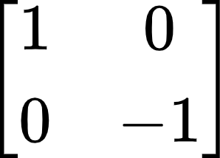
    - Reflection through the x₂ axis: 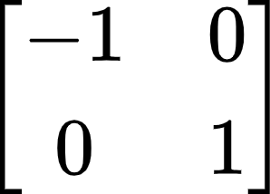
    - Reflection through the line x₂ = x₁: 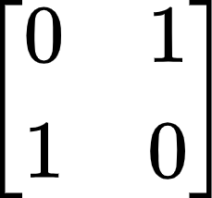
    - Reflection through the line x₂ = -x₁: 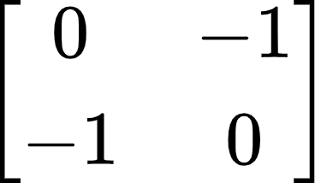
    - Reflection through the origin: 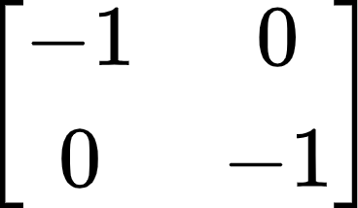
  - Contractions & expansions
    - 0 < k < 1: contraction
    - k > 1: expansion
    - Horizontal contraction & expansion: 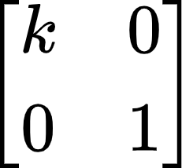
    - Vertical contraction & expansion: 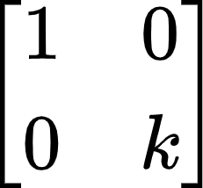
  - Shears
    - Horizontal shear: 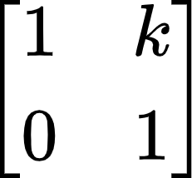
      - k < 0: left shear
      - k > 0: right shear
    - Vertical shear: 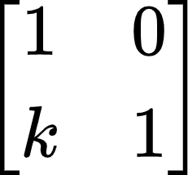
      - k < 0: down shear
      - k > 0: up shear
  - Projections
    - Projections on the x₁-axis: 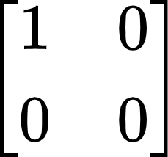
    - Projections on the x₂-axis: 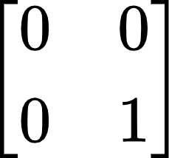
  - Rotation
    - CCW rotation: 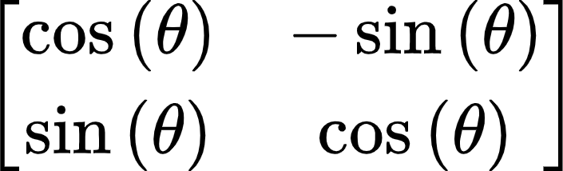
- Geometric description
  - Onto: can get to any vector with an image
  - One-to-one: cannot have multiple vectors have the same image
- Onto
  - A linear transformation T: R^{n} -> R^{m} is onto if for all b ∊ R^{m} there is an x ∊ R^{n} so that T(x) = Ax = b
    - Ax = b is always consistent
    - At least one solution
    - Existence property
  - T is onto if and only if its standard matrix has a pivot in every row
- One-to-one
  - A linear transformation T: R^{n} -> R^{m} is one-to-one if for all b ∊ R^{m} there is at most one (possible 0) x ∊ R^{n} so that T(x) = Ax = b
    - Ax = b has at most 1 solution
    - No free variables
    - Uniqueness property
  - T is one-to-one if and only if the only solution to T(x) = 0 is the trivial solution
  - T is one-to-one if and only if every column of A is pivotal

Section 2.1: Matrix Algebra
Key Notes
- Theorem 1
  - Let A, B, and C be matrices of the same size, and let r and s be scalars.
a. A + B = B + A d. r (A + B) = rA + rB
b. (A + B) + C = A + (B + C) e. (r + s) A = rA + sA
c. A + 0 = A f. r (sA) = (rs) A
- Matrix multiplication
  - If A is an m x n matrix, and if B is an n x p matrix with columns b₁, …, b_{p}, then the product AB is the m x p matrix whose columns are Ab₁, …, Ab_{p}
AB = A[b₁ b₂ … b_{p}] = [Ab₁ Ab₂ … Ab_{p}]
  - # of columns in A == # of rows in B
- Theorem 2: Properties of Matrix Multiplication
  - Let A be an m x n matrix, and let B and C have sizes for which the indicated sums and products are defined.
a. A (BC) = (AB) C
b. A (B + C) = AB + AC
c. (B + C) A = BA + BC
d. r (AB) = (rA) B = A (rB)
e. I_{m}A = A = AI_{n}
- Matrices that commute
  - Matrices A and B commute when AB = BA
- Warnings
  - Order when multiplying matrices matters
    - In general, AB ≠ BA
  - AB = AC does not suggest B = C
  - If AB is the zero matrix, cannot conclude in general that either A = 0 or B = 0
- Transpose of a Matrix
  - Given an m x n matrix, the transpose of A is the n x m matrix, denoted by A^{T}
  - 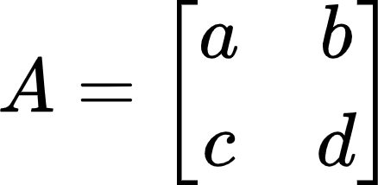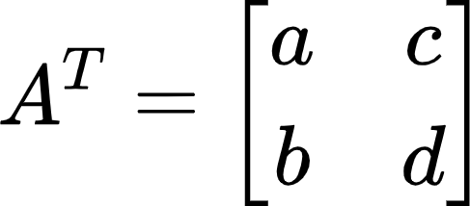
  - 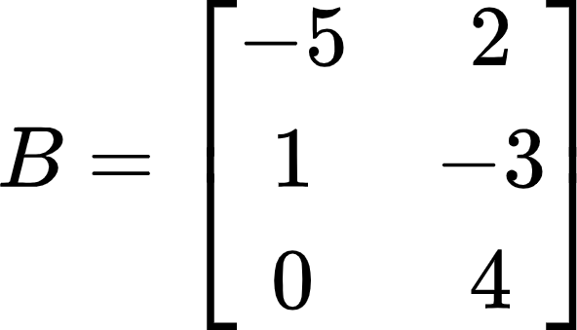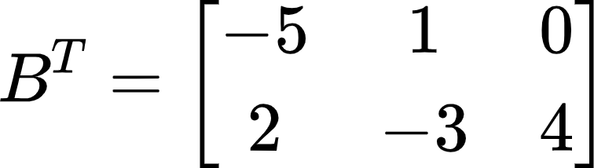
- Theorem 3
  - Led A and B denote matrices whose sizes are appropriate for the following sums and products
a. (A^{T})^{T} = A
b. (A + B)^{T} = A^{T} + B^{T}
c. For any scalar r, (rA)^{T} = rA^{T}
d. (AB)^{T} = B^{T}A^{T}
  - The transpose of a product of matrices equals the product of their transposes in the reverse order
- Powers of Matrices
  - Can only be applied to square matrices

Theorems
Theorem 1: Uniqueness of RREF
- Each matrix is row equivalent to one and only one row reduced echelon matrix.

Theorem 2: Existence and Uniqueness Theorem
- A linear system is consistent if and only if the rightmost column of the augmented matrix is not a pivot column - that is, if and only if an echelon form of the augmented matrix has no row of the form:
[0 … 0 b] with b nonzero
- If a linear system is consistent, then the solution set contains either:
i. a unique solution (no free variables)
ii. infinitely many solution (at least one free variable)

Theorem 3: Matrix, Vector, and Linear Equations
- If A is an m x n matrix, with columns a₁, … , a_{n} and if b is in R^{m}, the matrix equation
Ax = b
- has the same solution set as the vector equation
x₁a₁ + x₂a₂ + … + x_{n}a_{n} = b
- which, in turn, has the same solution set as the system of linear equations whose augmented matrix is
[a₁ a₂ … a_{n} | b]

Theorem 4: Logically Equivalent Statements
- Let A be an m x n matrix. Then the following statements are logically equivalent. That is, for a particular A, either they are all true statements or they are all false.
- For each b in R^{m}, the equation Ax = b has a solution.
- Each b in R^{m} is a linear combination of the columns of A.
- The columns of A span R^{m}.
- A has a pivot position in every row.

Theorem 5: Properties of the Matrix-Vector Product Ax
- If A is an m x n matrix, u and v are vectors in R^{n}, and c is a scalar, then:
- A (u + v) = Au + Av
- A ( cu ) = c (Au)

Theorem 6: Parametric Vector Form of a Nonhomogeneous System
- Suppose the equation Ax = b is consistent for some given b, and let p be a solution. Then the solution set of Ax = b is the set of all vectors of the form w = p + v_{h}, where v_{h} is any solution of the homogeneous equation Ax = 0.

Theorem 7: Characterization of Linearly Dependent Sets
- An indexed set S = {v₁, …, v_{p}} of two or more vectors is linearly dependent if and only if at least one of the vectors in S is a linear combination of the others. In fact, if S is linearly dependent and v₁ ≠ 0, then some v_{j} (with j > 1) is a linear combination of the preceding vectors, v₁, …, v_{j-1}.

Theorem 8: Linear Dependence based on Matrix Size
- If a set contains more vectors than there are entries in each vector, then the set is linearly dependent. That is, any set {v₁, …, v_{p}} in R^{n} is linearly dependent if the number of columns > than the number of rows.

Theorem 9: Linear Dependence based on a Zero Vector
- If a set S = {v₁, …, v_{p}} in R^{n} contains the zero vector, then the set is linearly dependent.

Theorem 10: Using the Standard Matrix to find Columns of A
- Let T: R^{n} -> R^{m} be a linear transformation. Then there exists a unique matrix A such that
T(x) = Ax for all x in R^{n}
- In fact, A is the m x n matrix whose jth column is the vector T(e_{j}), where e_{j} is the jth column of the identity matrix in R^{n}
A = [T(e₁) … T(e_{n})]

Theorem 11: One-to-One using the Homogeneous Equation
- Let T: R^{n} -> R^{m} be a linear transformation. Then T is one-to-one if and only if the equation T(x) = 0 has only the trivial solution

Theorem 12: Onto and One-to-One
- Let T: R^{n} -> R^{m} be a linear transformation, and let A be the standard matrix for T. Then:
a. T maps R^{n} onto R^{m} if and only if the columns of A span R^{m}
- All rows have pivots
b. T is one-to-one if and only if the columns of A are linearly independent
- All columns have pivots
- A has linearly independent columns

