Midterm 3
Section 5.3: Diagonalization
Definitions
- Diagonal matrix
  - A matrix where the only non-zero entries are on the main diagonal
  - Everywhere else is 0’s
- Similar matrices
  - A matrix A is similar to a matrix D if: A = PDP⁻¹
  - P is an invertible matrix
  - A & D have the same eigenvalues and determinant
  - IMPORTANT NOTE:
    - If two matrices are similar (same characteristic polynomial), then they have the same eigenvalues
    - CONVERSE IS NOT TRUE:
      - If two matrices have the same eigenvalues, that does not necessarily mean they are similar to each other
- Diagonalization
  - Splitting up a matrix A into a diagonal matrix D and an invertible matrix P
  - Useful to compute A^{k} for large k
- Algebraic multiplicity
  - The number of repeats for an eigenvalue
  - a_{i} = 2: eigenvalue appears twice
- Geometric multiplicity
  - The number of eigenvectors for a given eigenvalue
  - Dimension of Nul (A - λI) for a specific λ
- Singular = Not Invertible
  - Free variables
  - Linearly dependent columns
- Nonsingular = Invertible

Remarks
- Diagonalization Formula
  - A = PDP⁻¹
    - P: the set of all linearly independent eigenvectors
    - D: the corresponding eigenvalues (in order)
  - 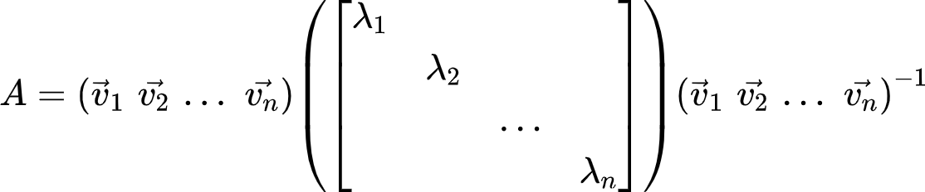
  - Allows us to solve A^{k} for large k
    - A² = PD(P⁻¹P)DP⁻¹ => PD²P⁻¹
    - A^{k} = PD^{k}P⁻¹
- The Diagonalization Theorem (Theorem 5)
  - An n x n matrix A is diagonalizable if and only if A has n linearly independent eigenvectors
    - Dimension of A = Dimension of P
  - A is diagonalizable if and only if there are enough eigenvectors to form a basis of R^{n}
    - Eigenvector basis
- Steps to Diagonalize a Matrix
  - Step 1: find the eigenvalues
    - det(A - λI) = 0
  - Step 2: find linearly independent eigenvectors of A
    - (A - λI)v = 0
      - Solve the null space
      - Parametric vector form
    - If # of total eigenvectors ≠ # of columns in A, then A is not diagonalizable (Theorem 5)
  - Step 3: construct P from vectors in Step 2
    - P = {v₁ v₂ … v_{n}}
  - Step 4: construct D from corresponding eigenvalues
    - D = {λ₁ λ₂ … λ_{n}}
- Theorem 6
  - An n x n matrix with n distinct eigenvalues is diagonalizable
  - Note:
    - It is not necessary for an n x n matrix to have n distinct eigenvalues in order to be diagonalizable
    - 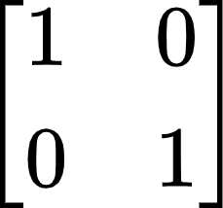: only 1 distinct eigenvalue but still has 2 eigenvectors
- Theorem 7: Matrices whose Eigenvalues are Not Distinct
  - Geometric multiplicity of λ must be less than or equal to the algebraic multiplicity of λ
    - g_{i}(λ) ≤ a_{i}(λ)
  - A matrix is diagonalizable if and only if the sum of the dimensions of the eigenspaces equals n (the number of columns)
    - Total geometric multiplicity == number of columns in matrix A
    - Characteristic polynomial of A factors completely into linear factors
    - Geometric multiplicity for each eigenvalue = algebraic multiplicity for each eigenvalue
- Diagonalizability and Invertibility have NO CORRELATION with each other
  - NEVER associate the word linearly independent, column space, null space, free variables, etc. with diagonalizable

Section 5.5: Complex Eigenvalues
Definitions
- Complex number: a + bi
  - Any number of the form: a + bi
  - i = 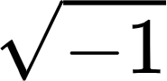
- Complex eigenvalue: λ
  - An eigenvalue that is a complex number: a + bi
    - Note: if b = 0, then λ is a real eigenvalue
- Complex eigenvector: x
  - An eigenvector subsisting of a complex eigenvalue
- Complex number space: ℂ^{n}
  - The space of all complex numbers
- ℂ²
  - A complex number space with 2 entries
  - At least one entry is a complex number
- Conjugate of a complex number
  - The conjugate for (a + bi) is (a - bi)
- Complex conjugate of a vector x
- Re x
  - The real parts of a complex vector x
  - An entry can be 0
- Im x
  - The imaginary parts of a complex vector x
  - An entry can be 0
- Argument of λ = a + bi
  - The angle φ produced by a and b on their respective Re x and Im x axis
  - 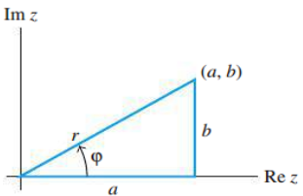

Remarks
- Finding complex eigenvalues and complex eigenvectors
  - Step 1: det(A - λ) = 0
    - Getting the eigenvalues: λ
    - If the characteristic equation produces complex roots, then those roots are the complex eigenvalues
  - Step 2: Solve (A - λI)x = 0 for x
    - Getting the eigenvectors: x
    - Will get something with the form:
      - 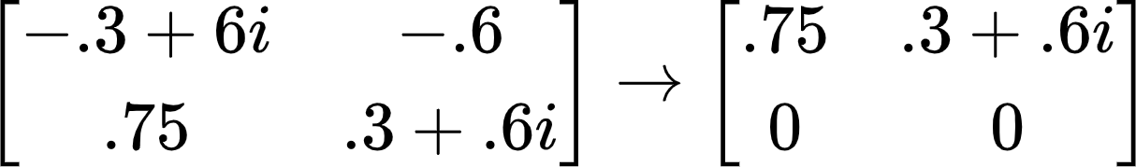
    - x:
      - 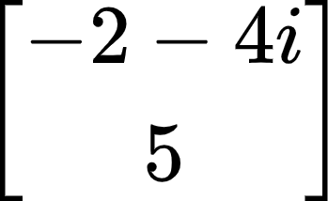
  - Step 3: Find the other eigenvector
    - Find the conjugate of the other eigenvector:
      - 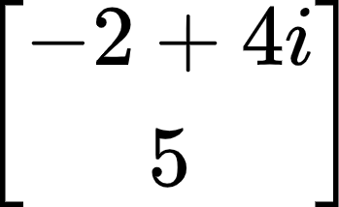
- Re x & Im x
  - : vector whose entries are the complex conjugates of the entries in x
  - 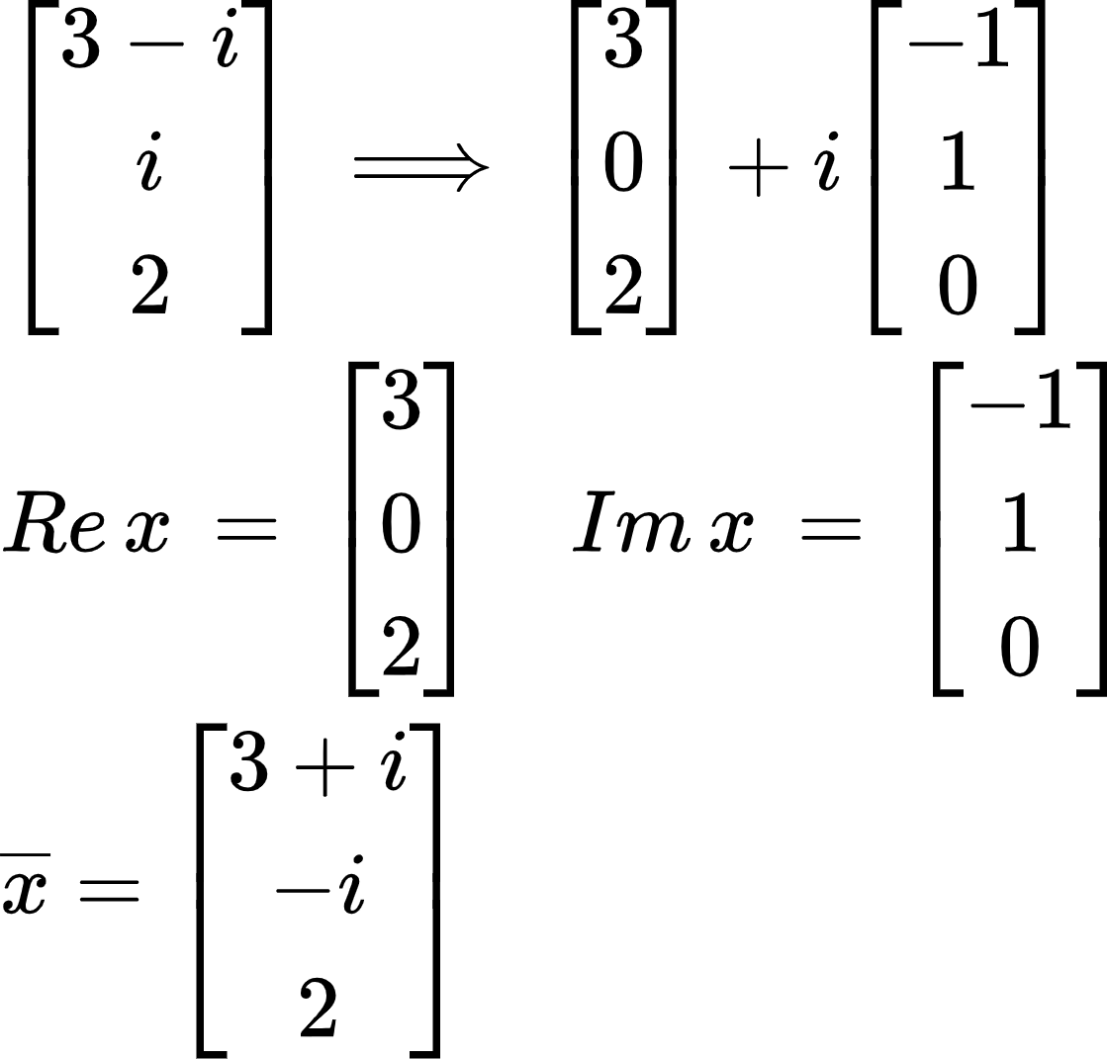
- Properties of Complex Conjugate Matrices
  - Where
    - r: scalar
    - x: vector
    - B: matrix
  - 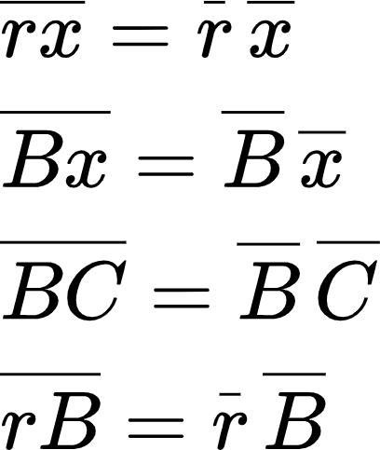
    - Basically, you can find the conjugates first, then multiply them together
- Complex Eigenvalues and Complex Eigenvectors Come in Pairs
  - 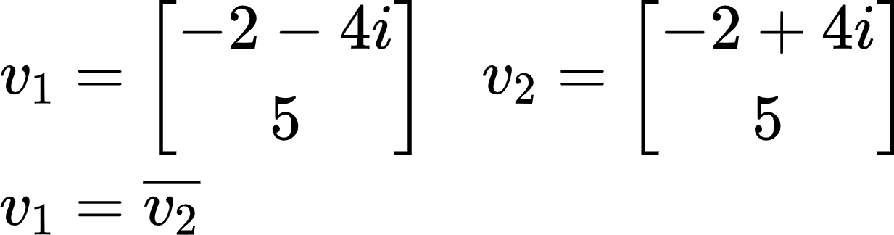
- The Meaning of a Matrix that Acts on ℂ^{n}
  - A transformation matrix that rotates then scales
  - 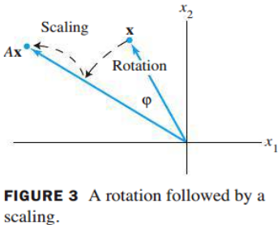
- Theorem 9
  - For A = real 2 x 2 matrix with (λ = a - bi , where b ≠ 0) and associated eigenvector v in ℂ² :
    - A = PCP⁻¹
      - P = [Re v Im v]
      - C = 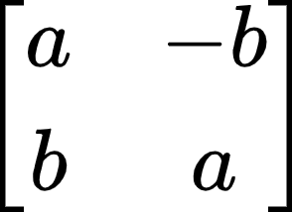=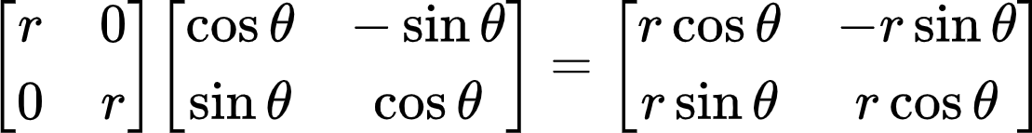
  - Why does this work?
    - A is 2 x 2 and has two eigenvalues (complex eigenvalues come in pairs)
    - C must be a 2 x 2 matrix as a result

Section 10.2: Google PageRank
Definitions
- Stochastic matrix
  - A matrix whose individual columns have an entry sum of 1
  - Always has at least one steady state
- Steady-state vectors
  - A probability vector q such that Pq = q
- Regular stochastic matrix
  - A stochastic matrix where for some power k, P^{k} contains entries all > 0
  - Always has a unique steady state
- Dangling nodes
  - Any column that represents a web page that is a dead end
  - Usually is the form of an elementary column: {e₁, e₂, … , e_{n}}

Remarks
- If P is a stochastic matrix, then a steady-state vector for P is a probability vector q such that
Pq = q
- Notes about stochastic matrices
  - Every stochastic matrix P has a steady-state vector q
  - 1 must be an eigenvalue of any stochastic matrix
  - A steady-state vector is a probability vector which is also an eigenvector of P associated with the eigenvalue 1
  - Non-regular stochastic matrices can have multiple steady state vectors
- Theorem 1
  - If P is a regular m x m stochastic matrix with m ≥ 2, then the following statements are true:
- There is a stochastic matrix Π such that $\lim_{n→∞}P^{n}=Π$
- Each column of Π is the same probability vector q
  - Would look something like this:
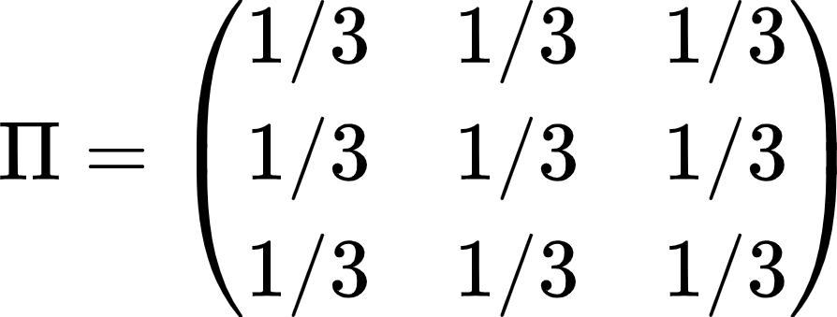
- For any initial probability vector $x_{0}$, $\lim_{n→∞}P^{n}x_{0}=q$
- The vector q is the unique probability vector which is an eigenvector of P associated with the eigenvalue 1
- The eigenvalues of P satisfy $\left|λ\right|≤1$
- PageRank
  - Adjustment 1:
    - Replace all dangling node columns with where n is the number of columns/rows
    - P* = P but with all dangling nodes replaced with the adjustment
  - Adjustment 2:
    - K =
  - Google Matrix Formula:
$G=0.85P_{*}+0.15K$

Section 6.1: Inner Product, Length, and Orthogonality
Definitions
- Inner product (dot product)
  - If u and v are vectors in ℝ^{n}, then the inner (dot) product of u and v is:
    - u^{T}v or:
    - $u∙v$
  - 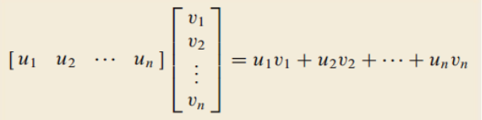
- Vector length: $\left|\left|v\right|\right|$
  - $\left|\left|v\right|\right|=\sqrt{v∙v}=\sqrt{v_{1}{}^{2}+v_{2}{}^{2}+...+v_{n}{}^{2}}$
- Unit vector
  - A vector whose length is 1
- Vector normalization
  - Dividing a nonzero vector by its length to make it a unit vector
- Distance between two vectors
  - $dist(u,v)=\left|\left|u-v\right|\right|$
- Orthogonal vectors
  - Two vectors are orthogonal if their dot product equals 0
- Orthogonal complements
  - A set of vectors that are all orthogonal to a subspace W
  - Representation as a line or plane depends on the null space of W
- What does it mean for a subspace to be in ℝ^{n}?
  - Subspace (contains zero vector and is closed under addition and multiplication) has n entries for each vector in it (dimension n)
  - Note: R¹ means that the vectors have one entry
    - Span of just [1]

Remarks
- Dot Product and Cross Product are Different
  - $u∙v=u{}^{T}v$
  - Dot product gives you a number
  - Cross product gives you a vector
- Theorem 1: Dot Product Properties
  - Where
    - u, v, and w are vectors in ℝ^{n}
    - c is a scalar in ℝ
- $u∙v=v∙u$
  - Symmetry
- $(u+v)∙w=u∙w+v∙w$
  - Linearity
- $(cu)∙v=c(u∙v)=u∙(cv)$
  - Scalars
  - Easy method: just find the dot product of the two vectors first, then multiply by the scalar
- $u∙u≥0$
  - Positivity
  - $u∙u=0$ if and only if u = 0
- Vector Length Properties
  - Vector length is always positive
  - $\left|\left|cv\right|\right|=\left|c\right|\left|\left|v\right|\right|$
  - $\left|\left|cv\right|\right|{}^{2}=c^{2}\left|\left|v\right|\right|{}^{2}$
- Normalizing a Vector
  - $v(\frac{1}{\left|\left|v\right|\right|})=u$
  - u: a unit vector
  - u is in the same direction as v, but u has different magnitude than v
- Finding the Distance between Two Vectors
  - Step 1: subtract the two vectors
    - u - v
  - Step 2: find the length of the resultant vector
    - $\left|\left|u-v\right|\right|$
- Rudimentary Notes about Orthogonality
  - Two vectors are orthogonal = two vectors are perpendicular to each other
  - $\left|\left|u-v\right|\right|=\left|\left|u-(-v)\right|\right|$
  - $u∙v=0$
  - Zero vector is orthogonal to every vector in ℝ^{n}
- Theorem 2: The Pythagorean Theorem
  - Two vectors are orthogonal if and only if ${\left|\left|u+v\right|\right|}^{2}={\left|\left|u\right|\right|}^{2}+{\left|\left|v\right|\right|}^{2}$
  - 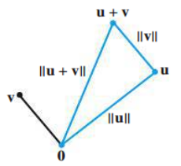
- Rudimentary Notes about Orthogonal Complements
  - What is an orthogonal complement?
    - It is a set of vectors where each vector is orthogonal to a subspace W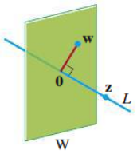
  - Orthogonal Complement of W = W⊥
    - A vector x is in W⊥ if and only if x is orthogonal to every vector in a set that spans W
      - Must calculate every single dot product pair to prove orthogonality
    - W⊥ is a subspace of ℝ^{n} ↔ W is also a subspace of ℝ^{n}
      - Both subspaces have n entries
      - They do not necessarily have the same dimension
        - dim(Row W⊥) = n - dim(Col W)
        - Could be 2,2 or 1,3 where n = 4
- Theorem 3
  - Let A be an m x n matrix:
    - (Row A)⊥ = Nul A
      - The row space of the orthogonal complement of A is the null space of A
    - (Col A)⊥ = Nul A^{T}
      - The column space of the orthogonal complement of A is the null space of A transpose
  - Proof
    - 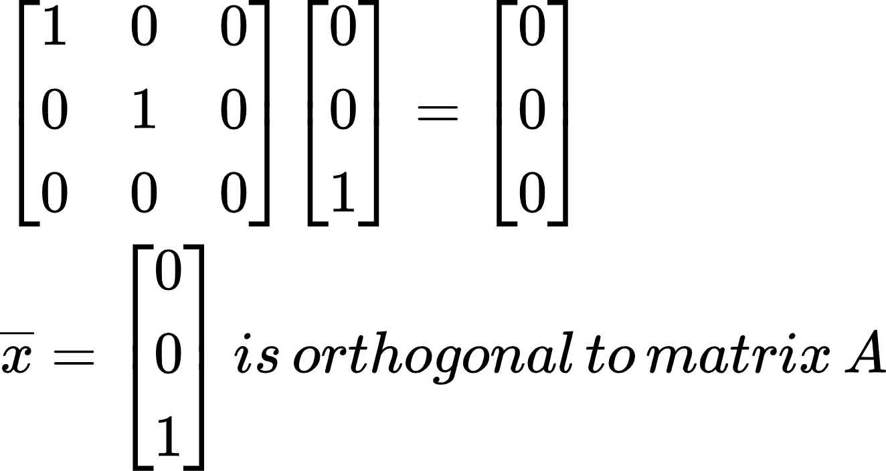
    - What is null space?
      - Av = 0
      - Essentially taking the dot product of every row of A with the vector v and seeing that v is orthogonal to A
- Rank Theorem
  - Row A
    - The space spanned by the rows of matrix A
    - Given by the pivot rows of A
    - dim(Row A) = dim(Col A)
      - # of pivot columns = # of pivot rows
    - Row A^{T} = Col A
  - N = # of columns in a matrix
    - N = dim(Col A) + dim(Nul A)
    - N = dim(Row A) + dim(Nul A)

Section 6.2: Orthogonal Sets
Definitions
- Orthogonal set
  - A set of vectors {u₁, …, u_{p}} in ℝ^{n} where each pair of distinct vectors from the set is orthogonal
  - $u_{i}∙u_{j}=0, u≠j$
- Orthogonal basis
  - A basis for a subspace W that is also an orthogonal set
- Orthogonal projection
  - Essentially projecting a vector onto a line/plane to get its orthogonal complement
  - $\hat{y}={proj}_{L} y=(\frac{y∙u}{u∙u})u$ L: subspace spanned by u
- Orthonormal set
  - An orthogonal set where every vector is a unit vector
- Orthonormal basis
  - A basis for a subspace W that is also an orthonormal set
- Orthogonal matrix
  - A square matrix whose columns form an orthonormal set

Remarks
- Theorem 4: Orthogonal Sets and Linear Independence
  - If $S=\{u_{1},...,u_{p}\}$is an orthogonal set of nonzero vectors in ℝ^{n}, then S is linearly independent and is a basis for the subspace spanned by S
- All orthogonal sets are linearly independent sets
  - However, not all linearly independent sets are orthogonal
  - Remember to omit the zero vector for an orthogonal set
- Theorem 5: Finding the Weights for a Linear Combination of an Orthogonal Basis
  - Let$\{u_{1},...,u_{p}\}$be an orthogonal basis for a subspace W of ℝ^{n}:
For every y in W, the weights in the linear combination
$y=c_{1}u_{1}+...+c_{p}u_{p}$
are given by:
$c_{j}=\frac{y∙u_{j}}{u_{j}∙u_{j}}$ (j = 1, …, p)
  - This method is better for finding the scalars than row reduction
    - However, this method is only applicable for orthogonal bases
- How to find an Orthogonal Projection
  - 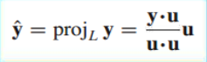
    - z: the component of y orthogonal to u
- Geometric Representations of an Orthogonal Projection
  - 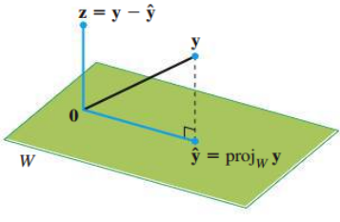
  - 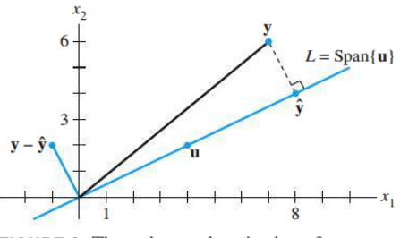
- Orthogonal Projections can be written as a Linear Combination of a Vector’s Components
  - $y=\left(\frac{y∙u_{1}}{u_{1}∙u_{1}}\right)u_{1}+(\frac{y∙u_{2}}{u_{2}∙u_{2}})u_{2}$
- All orthonormal sets are orthogonal
  - However, not all orthogonal sets are orthonormal
- Theorem 6: Transpose of a Matrix with Orthonormal Columns
  - An m x n matrix U has orthonormal columns if and only if $U^{T}U=I$
  - The transpose of a matrix with orthonormal columns multiplied by the original matrix always results in the identity matrix
    - Does it need to be square? NO!
  - Proof
    - 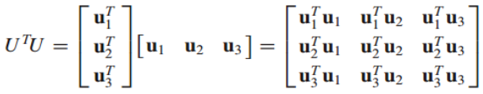
    - Main diagonal: all 1’s
      - Remember, an orthonormal vector times itself is the square root of its length, which equals 1!!!
    - Everywhere else: all 0’s
      - Remember, an orthonormal vector is also orthogonal, so two different vectors that are orthogonal to each other will have a product of 0
  - A^{T}A where A is a matrix with orthogonal columns (DIFFERENT)
    - Produces a diagonal matrix with all entries equal to each vector’s length squared
- Theorem 7: Properties of a Matrix with Orthonormal Columns
  - Let U be an m x n matrix with orthonormal columns, and let x and y be in ℝ^{n}:
    - $\left|\left|Ux\right|\right|=\left|\left|x\right|\right|$
      - Linear mapping 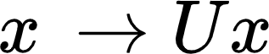 preserves length
    - $(Ux)∙(Uy)=x∙y$
    - $(Ux)∙(Uy)=0$ if and only if x and y are orthogonal to each other
      - Linear mapping preserves orthogonality
- Difference between Orthogonal Matrix and a Matrix with Orthonormal Columns
  - Orthogonal matrix must be square!!!
- U⁻¹ = U^{T}
  - The inverse of orthogonal matrices is its transpose
  - Orthogonal matrices have linearly independent columns
- Determinant of an Orthogonal Matrix
  - If A is an orthogonal matrix, then detA is equal to 1 or -1
  - Converse is NOT TRUE
    - If the determinant of a square matrix = 1, then the matrix must be orthogonal. => False
    - 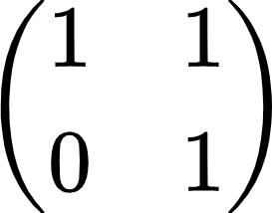

Section 6.3: Orthogonal Projections
Definitions
- ŷ: orthogonal projection of y onto W
  - ŷ = proj_{W}y
- z: orthogonal component of y onto W
  - z = y - ŷ
- Best approximation
  - $\left|\left|y-\hat{y}\right|\right|<\left|\left|y-v\right|\right|$
  - The vertical distance going straight up and down between a vector and its projection’s space
    - Any distance between a vector and a subspace that is not perpendicular to the space is automatically not the shortest distance

Remarks
- Properties of an orthogonal projection onto ℝ^{n}
  - 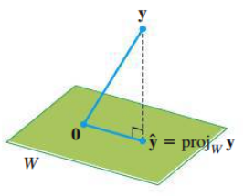
  - Given a vector y and a subspace W in ℝ^{n}, there is a vector ŷ in W such that:
    - ŷ is the unique vector in W for which $y-\hat{y}$ is orthogonal to W
    - ŷ is the unique vector in W closest to y
  - Key to finding least-squares solutions (6.5)
- Theorem 8: The Orthogonal Decomposition Theorem
  - Let W be a subspace of ℝ^{n}. Then each y in ℝ^{n} can be uniquely in the form
$y=\hat{y}+z$
where
ŷ is in W
z is in W⊥
  - If {u₁ , … , u_{p}} is any orthogonal basis of W, then
$\hat{y}=\frac{y∙u_{1}}{u_{1}∙u_{1}}u_{1}+...+\frac{y∙u_{p}}{u_{p}∙u_{p}}u_{p}$
    - $z=y-\hat{y}$
  - We assume W is not the zero subspace
    - Otherwise, W⊥ = ℝ^{n}
    - y = 0 + y
      - Everything projected onto the zero subspace is just the zero vector
- Properties of Orthogonal Projections
  - If y is in W = Span{u₁ , … , u_{p}}, then proj_{W}y = y
  - If y is already in the subspace, then projecting it onto the same subspace does not do anything
- Theorem 9: The Best Approximation Theorem
  - Let W be a subspace of ℝ^{n}, let y be any vector in ℝ^{n}, and let ŷ be the orthogonal projection of y onto W. Then ŷ is the closest point in W to y.
  - $\left|\left|y-\hat{y}\right|\right|<\left|\left|y-v\right|\right|$
for all v in W distinct from ŷ
  - 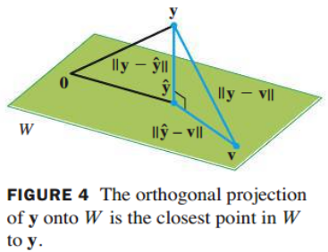
- Theorem 10
  - If {u₁ , … , u_{p}} is an orthonormal basis for a subspace W in ℝ^{n}, then
${proj}_{W}y=(y∙u_{1})u_{1}+(y∙u_{2})u_{2}+...+(y∙u_{p})u_{p}$
  - If U = [u₁ u₂ … u_{p}], then
${proj}_{W}y=UU^{T}y$ for all y in ℝ^{n}
  - Remember, if u₁ is a unit vector, then $u_{1}∙u_{1}=1$
- Theorem 10 using Matrix with Orthonormal Columns vs. Orthogonal Matrix
  - If U is an n x p matrix with orthonormal columns and W is the column space of U,
    - U^{T}Ux = I_{p}x = x for all x in ℝ^{p}
    - UU^{T}y = proj_{W}y for all y in ℝ^{n}
  - If U is an n x n matrix with orthonormal columns, then U is an orthogonal matrix
    - UU^{T}y = Iy = y for all y in ℝ^{n}
    - See end of 6.2

Section 6.4: The Gram-Schmidt Process
Definitions
- Gram-Schmidt process
  - Algorithm for producing an orthogonal/orthonormal basis for any nonzero subspace of ℝ^{n}

Remarks
- Theorem 11: The Gram-Schmidt Process
  - 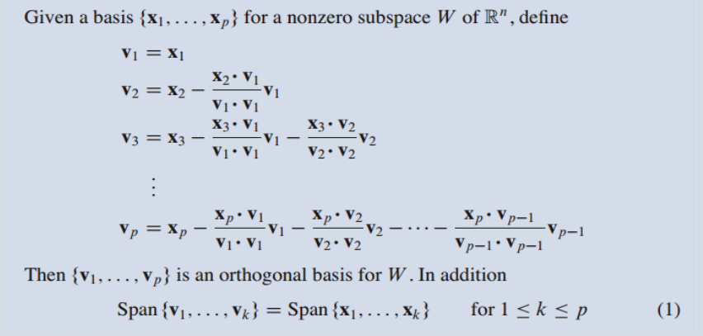
  - Remember: a basis is a set of linearly independent vectors that span a subspace W
    - # of vectors in a basis = # of pivot columns/rows
    - Gram-Schmidt requires a linearly independent basis (invertible/nonsingular)
  - Any nonzero subspace W of ℝ^{n} has an orthogonal basis because an ordinary basis {x₁ , … , x_{p}} is always available
- Orthonormal Bases
  - Simply normalize all vectors in an orthogonal basis {v₁ , … , v_{p}}
- Theorem 12: The QR Factorization
  - If A is an m x n matrix with linearly independent columns, then A can be factored as A = QR
Q: an m x n matrix whose columns form an orthonormal basis for
Col A
R: an n x n upper triangular matrix with positive entries on its
diagonal
  - Process
- Use Gram-Schmidt to find Q
- If needed, normalize the orthogonal basis given by Q
- Solve A = QR for R
  - R = Q^{T}A
  - If the columns of A were linearly dependent, then R would not be invertible

Section 6.5: Least-Squares Problems
Definitions
- General least-squares problem
  - Find x that makes $\left|\left|b-Ax\right|\right|$ as small as possible
- Normal equations
  - $A^{T}Ax=A^{T}b$
- Difference between x and $\hat{x}$
  - x just refers to some general solution
  - $\hat{x}$ is the solution that solves the least-squares problem/normal equations
- Least-squares error
  - Distance from b to $A\hat{x}$ where $\hat{x}$ is the least-squares solution to b
  - $\left|\left|b-A\hat{x}\right|\right|$

Remarks
- What is the motivation for solving least-squares problems?
  - Finding a close enough solution to Ax = b when it is an inconsistent system
- If A is m x n and b is in ℝ^{m}, a least-squares solution of Ax = b is an $\hat{x}$ in ℝ^{n} such that
$\left|\left|b-A\hat{x}\right|\right|≤\left|\left|b-Ax\right|\right|$
for all x in ℝ^{n}
  - If A is already consistent, then $\left|\left|b-A\hat{x}\right|\right|=0$
- Solution of the General Least-Squares Problem
  - Use the Normal Equations!!!
    - $A^{T}Ax=A^{T}b$
  - Derivation
    - 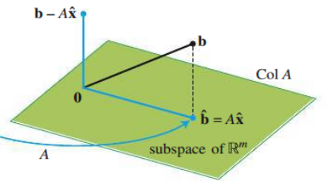
    - 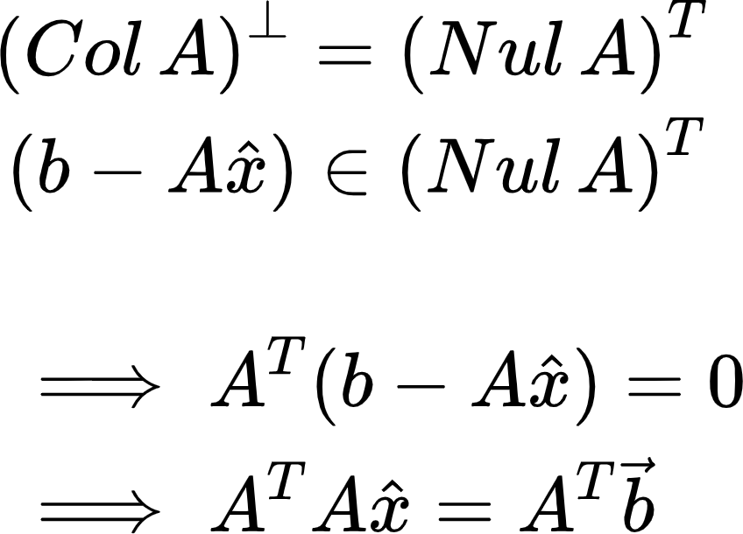
- Theorem 13
  - The set of least-squares solutions of Ax = b coincides with the nonempty set of solutions of the normal equations $A^{T}Ax=A^{T}b$
  - Possible to have more than one least-squares solution
    - Existence of a free variable ⇔ columns of A are linearly dependent
- Theorem 14
  - Let A be an m x n matrix. The following statements are logically equivalent
- The equation Ax = b has a unique least-squares solution for each b in ℝ^{m}
- The columns of A are linearly independent
- The matrix A^{T}A is invertible
  - When these statements are true, the least-squares solution $\hat{x}$ is given by:
$\hat{x}={(A^{T}A)}^{-1}A^{T}b$
- Calculating the Least-Squares Error
  - $\left|\left|b-A\hat{x}\right|\right|$
- Theorem 15: Finding the Least-Squares Solution using QR Factorization
  - Given an m x n matrix A with linearly independent columns, let A = QR be a QR factorization of A. Then, for each b in ℝ^{m}, the equation Ax = b has a unique least-squares solution, given by
$\hat{x}=R^{-1}Q^{T}b$
$R\hat{x}=Q^{T}b$
- What if b is orthogonal to the columns of A? What can we say about the least-squares solution of Ax = b?
  - If b is orthogonal to A, then the projection of b onto A is 0
  - A least-squares solution, $\hat{x}$, of Ax = b satisfies $A\hat{x}=0$

Section 6.6: Applications to Linear Models
Definitions
- Least-Squares Lines
  - $y=β_{0}+β_{1}x$
- Residual
  - Difference between the actual y-value and the predicted y-value

Remarks
- What is a Least-Squares Line?
  - It is basically a line of best-fit for a set of data
  - Least-squares lines minimize:
the sum of the squares of the residuals ⇔ the least-squares solution
- Objective:
  - Find $β_{0} and β_{1}$(coefficients) that create the least-squares line
  - Procedure using Normal Equations:
    - 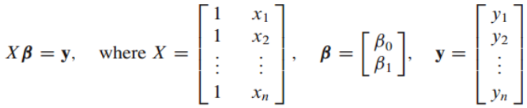
    - Use the normal equations to solve
    - 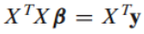
  - Procedure using Mean-Deviation Form:
    - Find the average of all the x-values: $\underline{x}$
    - Calculate $x^{*}=x-\underline{x}$ for each x
      - Do this but with the new x* values
- The General Linear Model
  - $y=Xβ+ϵ$
    - Solve the normal equations:
    - $X^{T}Xβ=X^{T}y$
  - Example:
    - 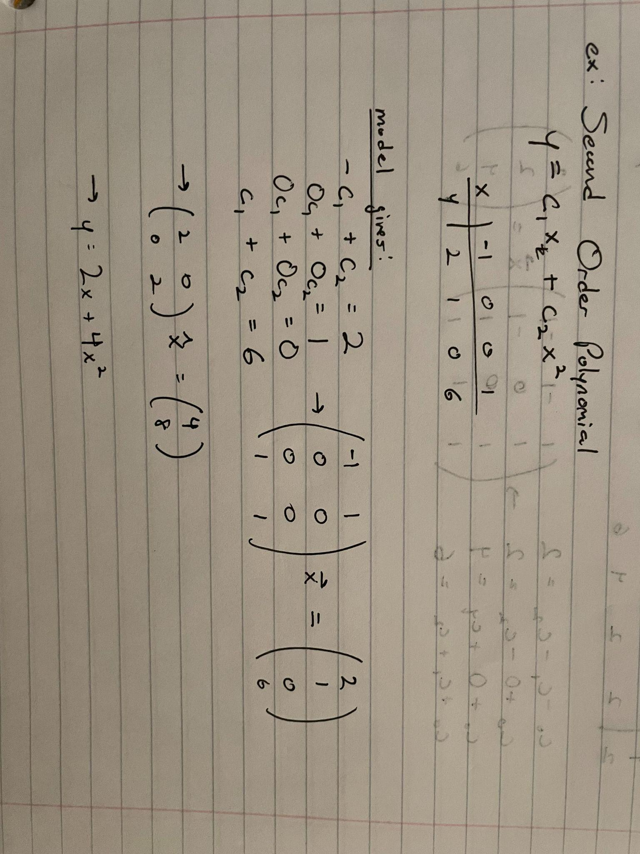
- Multiple Regression
  - Occurs when there are 2 or more independent variables
  - Example:
    - 